Alg 3 Name: ____________________________

______________ _____________

WS Assessment

Target 3:

Inequalities

**I can:**

* Solve inequalities, system of inequalities
* Write the equation or inequality that best models the problem
* Solve application problem using linear programming

**Unit 1: Solving Equation & Inequalities**

* **CCSS.Math.Content.HSA.CED.A.1**: Create equations and inequalities in one variable and use them to solve problems
* **CCSS.Math.Content.HSA.CED.A.2**: Create equations in two or more variables to represent relationships between quantities
* **CCSS.Math.Content.HSA.REI.A.2**: Solve simple rational and radical equations in one variable, and give examples showing how extraneous solutions may arise.
* **CCSS.Math.Content.HSA.CED.A.3**: Represent constraints by equations or inequalities, and by systems of equations and/or inequalities and interpret solutions as viable or nonviable options in a modeling context.
* **CCSS.Math.Content.HSA.CED.A.4**: Rearrange formulas to highlight a quantity of interest, using the same reasoning as in solving equations.

HW#3 Inequalities – [www.deltamath.com](http://www.deltamath.com)

Solve the inequality and graph the solution on the number line

$-19+2x ≤-21$ $-9+62x >-15$

$8x-2 ≥-18$ $-15+6x <-27$

$5+7x ≤26$ $4+5x ≤-31$

$-8x+4 >44$ $-3x+69 ≤54$

Solve the following inequality for n

$4n-6<10n+7$ $5n-2 ≤3n+8$

$9n+7 ≥10n -1$ $2n-5>6n-6$

$-2n-\left(-10n+7\right)≤2n- 4-9n$ $5-3\left(-7n+1\right)>-5n-3+9n$

$-10-\left(-8n-7\right)>3n-10-4n$ $6+4\left(-2n+9\right)≥n+2-7n$

Determine the smallest integer value of x in the solution of the following inequality

$-5x-1<5$ $-3x+10<15$

$4x-10>-17$ $3x+3>17$

Determine the largest integer value of x in the solution of the following inequality

$-4x+4>-12$ $5x-8<9$

Graphing the inequality on the given graph

$3x-2y≥14$ 5 $x+4y<-32$

|  |  |
| --- | --- |
|  |  |

Re-graph the above problem in calculator for stamp

Keith has $500 in a savings account at the beginning of the summer. He wants to have at least $200 in the account by the end of the summer. He withdraws $25 each week for food, clothes, and movie tickets.

Write an inequality that represents Keith's situation.

How many weeks can Keith withdraw money from his account? Justify your answer.

Yellow Cab Taxi charges a $1.75 flat rate in addition to $0.65 per mile. Katie has no more than $10 to spend on a ride. Write an inequality that represents Katie's situation.

How many miles can Katie travel without exceeding her budget? Justify your answer.

Fred bought 3 shirts, each of the same price and received less than $12 change from a $50 bill. What is the maximum cost of 1 shirt?

Solve the following system of inequalities graphically on the set of axes below. State the coordinates of **a point** in the solution set.

$y>\frac{1}{6}x+3$ $y≥\frac{3}{2}x-7$

$y≤-\frac{1}{2}x+7$ $y≥-x+3$

|  |  |
| --- | --- |
|  |  |

Use graphing calculator to solve the following system of inequalities graphically on the set of axes below. State the coordinates of **a point** in the solution set. Sketch and show me for stamp then just write down the point

$y>x^{2}+1$ $x^{2}+y^{2}<4$

$y<|3-x|$ $\left|y\right|<|-x|$

Solve by algebra and graph

Sam and Alex play in the same soccer team. Last Saturday Alex scored 3 more goals than Sam, but together they scored less than 9 goals. What are the possible number of goals Alex scored?

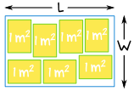A rectangular room fits at least 7 tables that each have 1 square meter of surface area. If the perimeter of the room is not more than 16 m. What could the width and length of the room be?

Kelly can work for her dad and make $6.00 per hour, or she can work for Jana's Mowing Service and make $14.00 per hour. If she needs to make at least $84, and can only work 10 hours total.  She can work at most 5 hours for Jana's Mowing Service. Write and graph a system of equations that represents all the possible solutions.

Otto Toyom builds toy cars and truck. To make each car, he needs 4 wheels, 2 seats and 1 gas tank. To make each truck, he needs 6 wheels, 1 seat and 3 gas tanks. His storeroom has 36 wheels, 14 seats, and 15 gas tanks. He is trying to decide how many cars and trucks to build so he can make the largest possible amount of money when he sells them.

What are the constrain when building car and truck? (spell out less than or more than)

Wheels Seats Gas tank

With your group decides at least 4 solutions (1 person each?) of how many car and truck he can make from the materials in his storeroom.

Car Truck Car Truck

|  |  |  |  |  |  |  |
| --- | --- | --- | --- | --- | --- | --- |
| Person 1 |  |  |  | Person 3 |  |  |
| Person 2 |  |  |  | Person 4 |  |  |

Which one of the 4 solutions above give Otto the greatest profit if he makes $2 for each truck and $1 for each car. Show work

Person 1 Person 2

Person 3 Person 4

Now we approach this problem from different point of view (it called Linear Programming)

|  |  |  |  |  |
| --- | --- | --- | --- | --- |
|  | Wheel (? ____) | Seat (? _____) | Tank (?_______) |  |
| For Car: _____ |  |  |  |  |
| For Truck: _____ |  |  |  |  |
| Total both |  |  |  |  |
| Constrain |  |  |  |  |
| Car: ___ > 0 | Truck ___ > 0 |  |  |  |

Convert and graph all 5 inequalities on the graph and find vertex of the overlap area

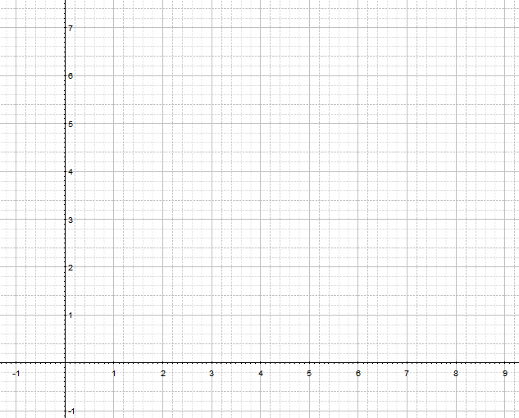

Show me this graph on desmos for stamp ____________________

Now set up the calculation to find the profit

The Sandy Dandy Dune Buggy Company makes two popular models of off-road vehicles: the Crawler and the Rover. Each week, they receive enough parts to build at most 15 Crawlers and 12 Rovers. The only exceptions to the supply of parts are the colored night lamps and high-definition speakers, which have to be specially manufactured for our off-road vehicles. Each of the Crawlers requires 5 of the lamps and 2 of speakers. The Rover requires 3 lamps and 6 speakers. The supply company for them can only manufacture 81 of the lamps and 78 of the speakers each week. They have 12 employees and by contract, the maximum number of hours each employee can work is 37.5 hours per week. It takes 20 hours to assemble one Crawler and 30 hours to assemble one Rover. Each Crawler sold brings in a profit of $500 and Rover is $1000 each. Write a proposal to maximize the profits by showing how many of each type of vehicles should be assembled.

What are the constrain? (spell out less than or more than)

|  |  |  |  |  |
| --- | --- | --- | --- | --- |
|  | Lamp (? ____) | Speaker (? ____) | Time (?_______) | Other info |
| Crawler: _____ |  |  |  |  |
| Rover: ______ |  |  |  |  |
| Total both |  |  |  |  |
| Constrain |  |  |  |  |
|  |  |  |  |  |

Convert and graph all 5 inequalities in desmos on the graph and find vertex of the overlap area

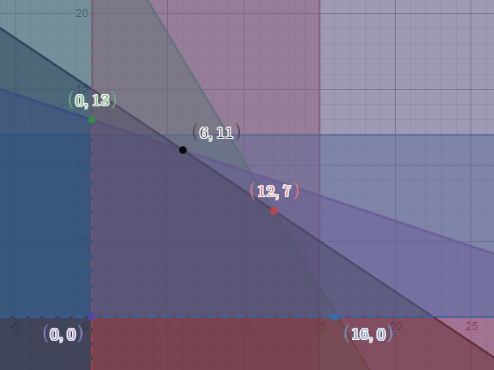

Show me for stamp. Set up the calculation to find the profit

Fred's Coffee sells two blends of beans: Yusip Blend and Exotic Blend. Yusip Blend is one-half  
Costa Rican beans and one-half Ethiopian beans. Exotic Blend is one-quarter Costa Rican beans and three-quarters Ethiopian beans. Profit on the Yusip Blend is $3.50 per pound, while profit on the Exotic Blend is $4.00 per pound. Each day Fred receives a shipment of 200 pounds of Costa Rican beans and 330 pounds of Ethiopian beans to use for the two blends. How many pounds of each blend should be prepared each day to maximize profit? What is the maximum profit?

Show me graph for stamp, then set up the calculation to find profit.

A calculator company produces a scientific calculator and a graphing calculator. Long-term projections indicate an expected demand of at least 100 scientific and 80 graphing calculators each day. Because of limitations on production capacity, no more than 200 scientific and 170 graphing calculators can be made daily. To satisfy a shipping contract, a total of at least 200 calculators much be shipped each day. If each scientific calculator sold results in a $2 loss, but each graphing calculator produces a $5 profit, how many of each type should be made daily to maximize net profits?

**Assessment Target 3**

**I can…** solve inequalities and system of inequalities problems

1. Solve the inequality and graph the solution on the number line

2. Alex sells books online. She makes a flat profit of $2.00 per book, but she needs to pay $4.00 per day to Paypal for using the app on her website. How many books does she need to sell to make at least $120.00 per day? Show inequalities solution

|  |  |
| --- | --- |
| 3. Solve the following system of inequalities graphically on the set of axes below. State the coordinates of **a point** in the solution set. $y>-2x-5$ $y≥x+8$ | 4. In basketball you score 2 points for a field goal and 1 point for a free throw. Suppose that you have scored at least 3 points in every game this season, and have a season high score of at most 15 points in one game. How many field goals and free throws could you have made in any one game? Write a system of two inequalities that describes this situation. b. Graph the system on graphing calculator for **stamp** and write down to show all possible outcomes. |

You would like to maximize profits at your bakery, which makes decorated sheet cakes for parties in two sizes, a full sheet and a half sheet. A batch of 12 full-sheet cakes takes 3.5 hours of oven time and 4 hours of decorating time, whereas a batch of 20 half-sheet cakes takes 5 hours of oven time and 2 hours of decorating time. The oven is available for a maximum of 21 hours a day, and the decorating room is available for 14 hours a day. Let x represent the number of batches of sheet cakes that the bakery produces in one day, and let y represent the number of batches of half-sheet cakes. The bakery makes a profit of $30 on each batch of full-sheet cakes and $35 on each batch of half-sheet cakes. The bakery must bake at least one batch of each kind to meet customer needs. What is the maximum profit? You need to graph out here and also show me in desmos for stamp. Show all details work.